2

Mehmetcan Caniklioglu

Student number: 14477378

Word count: 2487

Supervisor: Dr. K. Mavromatis

07/04/2023

Technology, TRADE and Occupational Employment

A Cross-Country Analysis of Technology and Trade’s Impact on Occupational Employment and Inequality

Table of Contents

1. Introduction 3

2. View From the Shoulders of Giants: Survey of Current Literature 5

2.1 Technology and Heterogenous Labor 5

2.2 Skills, Tasks and Occupations 7

2.3 Trade in Tasks: Offshoring 8

2.4 Empirical Challenges and Data Sources 8

3. Data Sources 10

4. Recent Trends in the European Union Labor Markets 10

5. Theoretical Framework 10

6. Results of Empirical Analysis 10

7. Conclusion 10

8. Bibliography 10

*\* Preliminary deadlines are in parenthesis.*

# Introduction

As technology shapes the economy, the products we consume and produce changes and this change influences the relative demand for factors of production. Even though the generic production functions used in economic analysis and modelling generally accepts capital and labor as monolithic flow variables, it is necessary to introduce heterogeneity to the labor variable to explain recent developments in labor markets such as diverging labor earnings, job polarization and offshoring.

Economists put respectable effort to characterize these effects and its implications on different subsets of labor force to understand the observed patterns in the distribution of earnings and skill premia. My initial research revealed that economists discuss the characteristics of technical change with several economic hypotheses which are used to examine the interactions between different types of workers and machines (i.e., capital), such as skill-biased technological change (SBTC), capital-skill complementarity (CSC), and routine-biased technological change (RBTC) (Goos, 2018).

SBTC suggests that technological progress augments the labor productivity of skilled workers more than unskilled workers, thereby increasing the demand for skilled workers relative to unskilled workers, leading to an increase in demand for skilled labor and hence elevate the skill premium. CSC assumes that capital and skill are relative complements, so capital deepening increases the demand for skilled relative to unskilled labor, leading to an increase in the skill premium. RBTC posits that technological progress replaces workers doing routine tasks, and self-selection of workers with different skill levels occurs.

While the technology evolves the demand structure for different factors in the production, labor market faced several developments which I want to put emphasis in this research as mentioned above.

*Job-Polarization* can be defined as the increase in the relative demands for high and low skilled occupations accompanied with a sharp decline in the demand for middle skill occupations. Katz and Autor (1998) who found that there was a compression of skill differentials and wage inequality in most industrialized economies during the 1970s, followed by a rise in differentials in the 1980s, with the highest increase seen in the U.S. and U.K. Atkinson, using data for 19 OECD countries, reports that there was a rise in either upper-tail or lower-tail inequality in 16 countries between 1980 and 2005, with seven countries experiencing a rise in both tails.

*Off-shoring* is another development that the modern economy experienced with the ever-globalizing world. based on the findings of Autor, Levy, and Murnane (2003), the emergence of new technological advancements has made it possible for information and communication technologies to take over or facilitate the outsourcing of specific essential job tasks formerly carried out by middle-skilled workers. By its definition offshoring can be seen as trade in tasks which is expected to affect the relative demands for different task and therefore different skills. Consequently, this has led to a significant alteration in the benefits of a particular skill group and a noticeable change in the way skills are assigned to various tasks.

All the defined characteristics of technological change has been argued and tested by economist to fit observations in the labor market mentioned above, thought I am going to focus mainly on SBTC and offshoring to explain the recent developments in the European Union Labor market(s), particularly discussed and implemented in production and labor economics framework suggested by Acemoglu and Autor (2011).

The research question to answer is:

**How did the recent developments in technology and offshoring activity in European Union affected demand for different skills and earnings of different occupations in late 20th and 21st Century?**

This paper will proceed as follows: Chapter 2 summarizes the literature. Chapter 3 introduces the data sources to be employed in the research, Chapter 4 presents the recent trends in the European Union Labor markets, Chapter 5 introduces the Theoretical Framework to be Utilized, Chapter 6 discusses the results of the empirical estimation and lastly Chapter 7 concludes the discussion and presents the outcomes of the research.

# View From the Shoulders of Giants: Survey of Current Literature

## Technology and Heterogenous Labor

First steppingstones for modelling the relationship between technology and heterogeneity on labor earnings, was mentioned by Tinbergen (1974, 1975) as the concept of a competition between the demand for and supply of education, where technology plays a significant role in determining both sides.

The idea of a competition between the need for and availability of skill (education) was later popularized by various economists to explain the alterations occurring in the labor market and the distributive effects of the fundamental characteristic of technical change shaping the demand for skill.

The literature on the link between education and wages starts with the observation that despite the increase in the number of college-educated workers, the relative wages of college graduates compared to high school graduates showed an increasing trend during late 20th century (Katz and Murphy, 1992; Acemoglu, 2002). These findings motivated economist to question “How did the demand for skill has also increased, alongside the supply of skills?”. 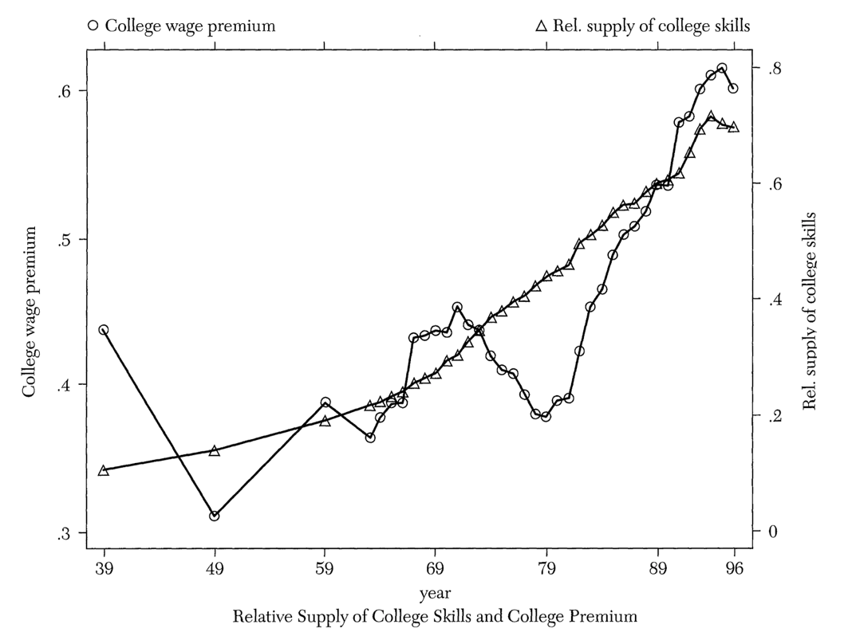

Figure 1  The Behavior of the (log) College Premium and Relative Supply of College Skills adapted from “Technical change, inequality, and the labor market” by Acemoglu D.

Consensus among the economists explaining the increasing earning gap between skilled and unskilled labor is the hypothesis of skill biased technical change. One can relate this theory to the endogeneity of innovation as Scherer (1982) argues that the profit seeking research sector optimizes its expected profits and thereby generating skill complementary Technologies when the supply of skill increases.

Figure 2 Relative Demand for Skill adapted from “Technical change, inequality, and the labor market” by Acemoglu D.

Another significant perspective explaining the role of SBTC in wage inequalities was defined through the process of computerization. It is argued that the introduction of computers into the workplace has led to a shift in demand for different types of labor (Autor, Katz and Krueger 1998). Specifically, SBTC is closely related to computerization as computer technology has advanced, it has become more important for workers to have strong technical and analytical skills to remain competitive in the labor market.

A widely accepted and appreciated approach was developed by Katz and Murphy (1992) to explain the observed increase in wage gap between skilled and unskilled workers in US between 1963 and 1987. Their analysis revealed that changes in the relative supply of skilled and unskilled labor had a modest effect on wage inequality, while the skill-biased technical change had a significant impact on the demand for skilled workers and therefore on the wage gap.

The Katz and Murphy framework, referred as “canonical model” in Acemoglu and Autor (2011), includes two skill groups performing two distinct yet imperfectly substitutable occupations (or producing two imperfectly substitutable goods). Technology is assumed to take a factor-augmenting form, and thus enhances either high or low skill workers' abilities and SBTC is captured by changes in this factor-augmenting technology.

Equation 1 CES Production Function of Katz and Murphy Framework,

Where are factor Augmenting technology terms,

## Skills, Tasks and Occupations

While the Katz and Murphy framework has proved to be empirically successful on explaining the relationship between technical change and earning distribution for late 20th century (Katz and Murphy,1992; Autor Katz and Krueger, 1998; Riddell and Romer, 1998), critics on certain attributes of the model has raised and generated further modifications on explaining 21st century phenomena happening in labor market. One study focusing on the phenomena of 21st century US Labor markets, namely “off shoring” and “job polarization”, was proposed by Acemoglu and Autor (2011).

Before Diving in further explanations, it would be convenient to provide certain definitions regarding the framework inherited by Acemoglu and Autor (2011).

A task is defined as “Unit of work activity that produces output (goods and services)”. In contrast, a skill is defined as “Worker’s endowment of capabilities for performing various tasks”. Labors apply their skills to tasks in exchange for labor income, and skills applied to tasks produce output.

What Acemoglu and Autor prosed was to add another layer of assignment (replacing skill-to-output mapping with skill-to-task-to-output mapping) to explain the impact of technological changes on employment and wages through changes in the allocation of skills to tasks. Another they modification proposed by Acemoglu and Autor was to add a middle skilled cluster of labor and introducing further segmentation on labor force to investigate the job polarization.

Equation 2 Production Function of Acemoglu and Autor,

Where , , are low skill, medium skill, high skill and capital biased technologies respectively and are task productivity schedules

Furthermore, in Acemoglu and Autor framework the authors defined the technological change as an endogenous variable to explain the time-varying behavior of SBTC. In contrast, the canonical model treats technology as exogenous and assumes that technical change is “by its nature” skill biased. However, evidence suggests that the degree of skill bias of technical change has differed over time and across countries. Acemoglu (1998, 2002) proposed that the endogenous response of technology to labor market conditions may explain various pace and characteristics (i.e., skill/capital-complementing/substituting) and considerably enhance the canonical model.

## Trade in Tasks: Offshoring

In their paper, Autor, Dorn, and Hanson (2013) examine the impact of trade and technology on local labor markets in the United States. They find that both trade and technology have led to significant shifts in the types of jobs available in certain areas, and that these shifts have had important consequences for workers and local economies. The authors argue that policies aimed at helping workers adjust to these changes, such as retraining programs and income support, are crucial for ensuring that the benefits of trade and technological progress are widely shared.

Also, Feenstra and Hanson (1996) investigate the impact of globalization and outsourcing on wage inequality in the United States during the 1980s and 1990s. They find evidence that increased trade with low-wage countries and the outsourcing of production to these countries has contributed to the widening wage gap between skilled and unskilled workers in the US.

## Empirical Challenges and Data Sources

Measuring technology and offshoring is an obstacle to conduct the analysis required to answer the research question this study. Though there are several approaches proposed by various researchers to overcome this challenge.

Autor, Levy, and Murnane (2003) deployed empirical methods to explore the relationship between technological change and the demand for different types of skills. They employ both cross-sectional and longitudinal data from the US Census and the Dictionary of Occupational Titles to examine changes in the demand for different types of skills over time.

Like Autor, Levy, and Murnane; Firpo, Fortin and Lemieux (2012) produced indexes for all 3-digit occupations in the CPS, incorporating criticisms of Blinder's work on offshorability indexes. They address the importance of *face-to-face and on-site interactions* in their construction of indexes, which is often neglected in objective measures. They use the O*NET to organize job information into different categories in measuring *routine vs. non-routine* and *cognitive vs. non-cognitive* aspects of occupations.

On the other hand, Welsum and Reif (2005), uses panel data estimation techniques to examine factors associated with the share of employment potentially affected by offshoring in the US, Canada, Australia, and EU15 countries (excluding Greece, Ireland, Luxembourg, and Portugal) between 1995 and 2003. The model includes variables related to *trade, investment, industrial structure, technology adoption, product market regulations, employment protection, and human capital*.

In addition to the data sources and methodologies mentioned above, this research will test foreign direct investment outflows as a proxy to measure outsourcing in the empirical studies.

*Potential Data Sources:*

|  |  |
| --- | --- |
| Data Source | Variable |
| European Union Labor Force survey (ELFS) | Occupation level labor Supplies |
| OECD STAN | Industry level Outputs |
| The World Bank Group | Foreign Direct Investment |
| Penn Table | Macroeconomic (Control) Variables |
| UN Comtrade Database | Trade Quantities |
| European Community Household Panel (ECHP) | Occupation level labor Earning |
| European Union Statistics on Income and  Living Conditions (EU-SILC) | Occupation level labor Earning |

# Bibliography

Acemoglu, D. (1998). Why do new technologies complement skills? Directed technical change and wage inequality. The Quarterly Journal of Economics, 113(4), 1055-1089.

Acemoglu, D. (2002). Technical change, inequality, and the labor market. Journal of Economic Literature, 40(1), 7-72.

Acemoglu, D., & Autor, D. (2011). Skills, Tasks and Technologies: Implications for Employment and Earnings. Handbook of Labor Economics, 4, 1043-1171.

Autor, D. H., Katz, L. F., & Krueger, A. B. (1998). Computing inequality: Have computers changed the labor market? Quarterly Journal of Economics, 113(4), 1,165–1,194.

Autor, D. H., Levy, F., & Murnane, R. J. (2003). The Skill Content of Recent Technological Change: An Empirical Exploration. *The Quarterly Journal of Economics*, *118*(4), 1279–1333.

Autor, D. H., Dorn, D., & Hanson, G. H. (2013). Untangling trade and technology: Evidence from local labor markets. The Economic Journal, 123(12), 52-104.

Blinder, A. S., & Krueger, A. B. (2013). Alternative Measures of Offshorability: A Survey Approach. Journal of Labor Economics, 31(2), S97–S128.

Feenstra, R. C., & Hanson, G. H. (1996). Globalization, outsourcing, and wage inequality. National Bureau of Economic Research. (Working Paper No. 5424).

Firpo, S., Fortin, N. M., & Lemieux, T. (2012). Occupational tasks and changes in the wage structure. IZA Discussion Paper, 6328.

Goos, M. (2018). The impact of technological progress on labour markets: policy challenges. Oxford Review of Economic Policy, 34(3), 362–375.

Goos, M., Manning, A., & Salomons, A. (2010). Explaining job polarization in Europe: The roles of technology, globalization, and institutions. CEP Discussion Paper No 1026.

Katz, L. F., & Murphy, K. M. (1992). Changes in the relative wages, 1963-1987: Supply and demand factors. The Quarterly Journal of Economics, 107(1), 35-78.

Katz, L. F., & Autor, D. H. (1998). Changes in the Wage Structure and Earnings Inequality. NBER Working Paper No. 6536. National Bureau of Economic Research.

Riddell, W. C., & Romer, P. M. (1998). Wages, Skills, and Technology in the United States and Canada. In D. Card & R. Freeman (Eds.), Small Differences That Matter: Labor Markets and Income Maintenance in Canada and the United States (pp. 45-97). University of Chicago Press.

Scherer, F. M. (1982). Demand-Pull and Technological Invention: Schmookler Revisted. *The Journal of Industrial Economics*, *30*(3), 225–237. https://doi.org/10.2307/2098216

Tinbergen, Jan, “Substitution of Graduate by Other Labor,”Kyklos 27 (1974), 217-226.

Tinbergen, Jan, Income Difference: Recent Research, Amsterdam: North-Holland Publishing Com- pany, 1975.

Welsum, D., & Reif, X. (2005). Potential offshoring: Evidence from selected OECD countries. OECD.